**AWS SNS Service**

AWS SNS Service is a service that allows you to automate the sending of email or text message notifications, based on events that happen in AWS Account.

This service is a web service that coordinates and manages the delivery or sending of messages to subscribing endpoints or clients.

There are two types of clients:-

(i) Publishers:- The Publishers communicate asynchronously with subscribers by producing and sending a message to topic, which is a logical access point and communication channel.

(ii) Subscribers:- The Subscribers consume or receive the message or notification over one of the supported protocols when they are subscribed to the topic.

Step 1. Search SNS in the search box of AWS Console.

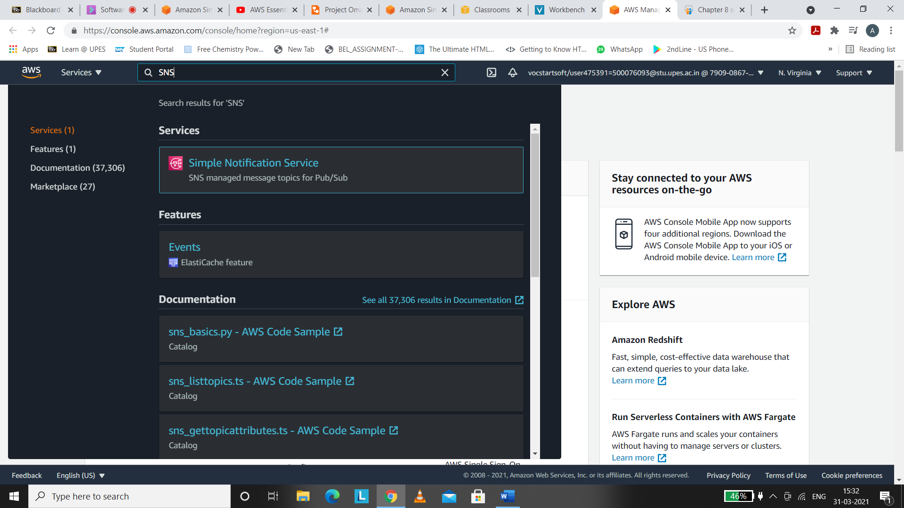

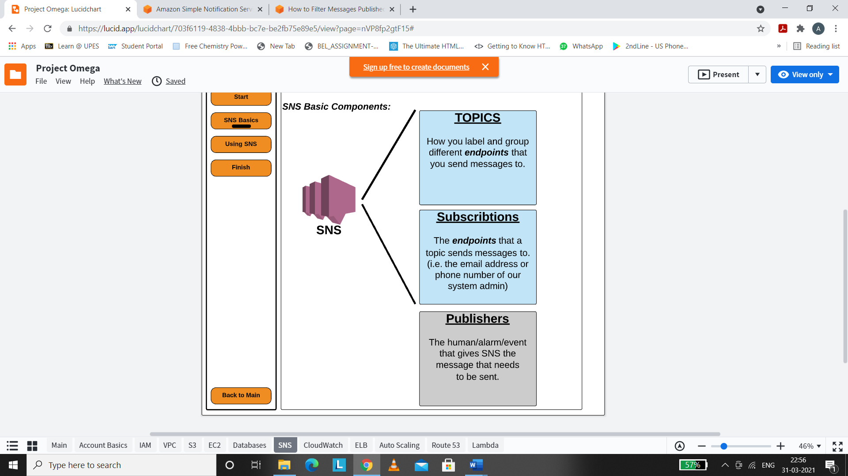

Step 2. Create a Topic and give a suitable name to that particular topic. These topics will help us to label and group different endpoints that you send messages on.

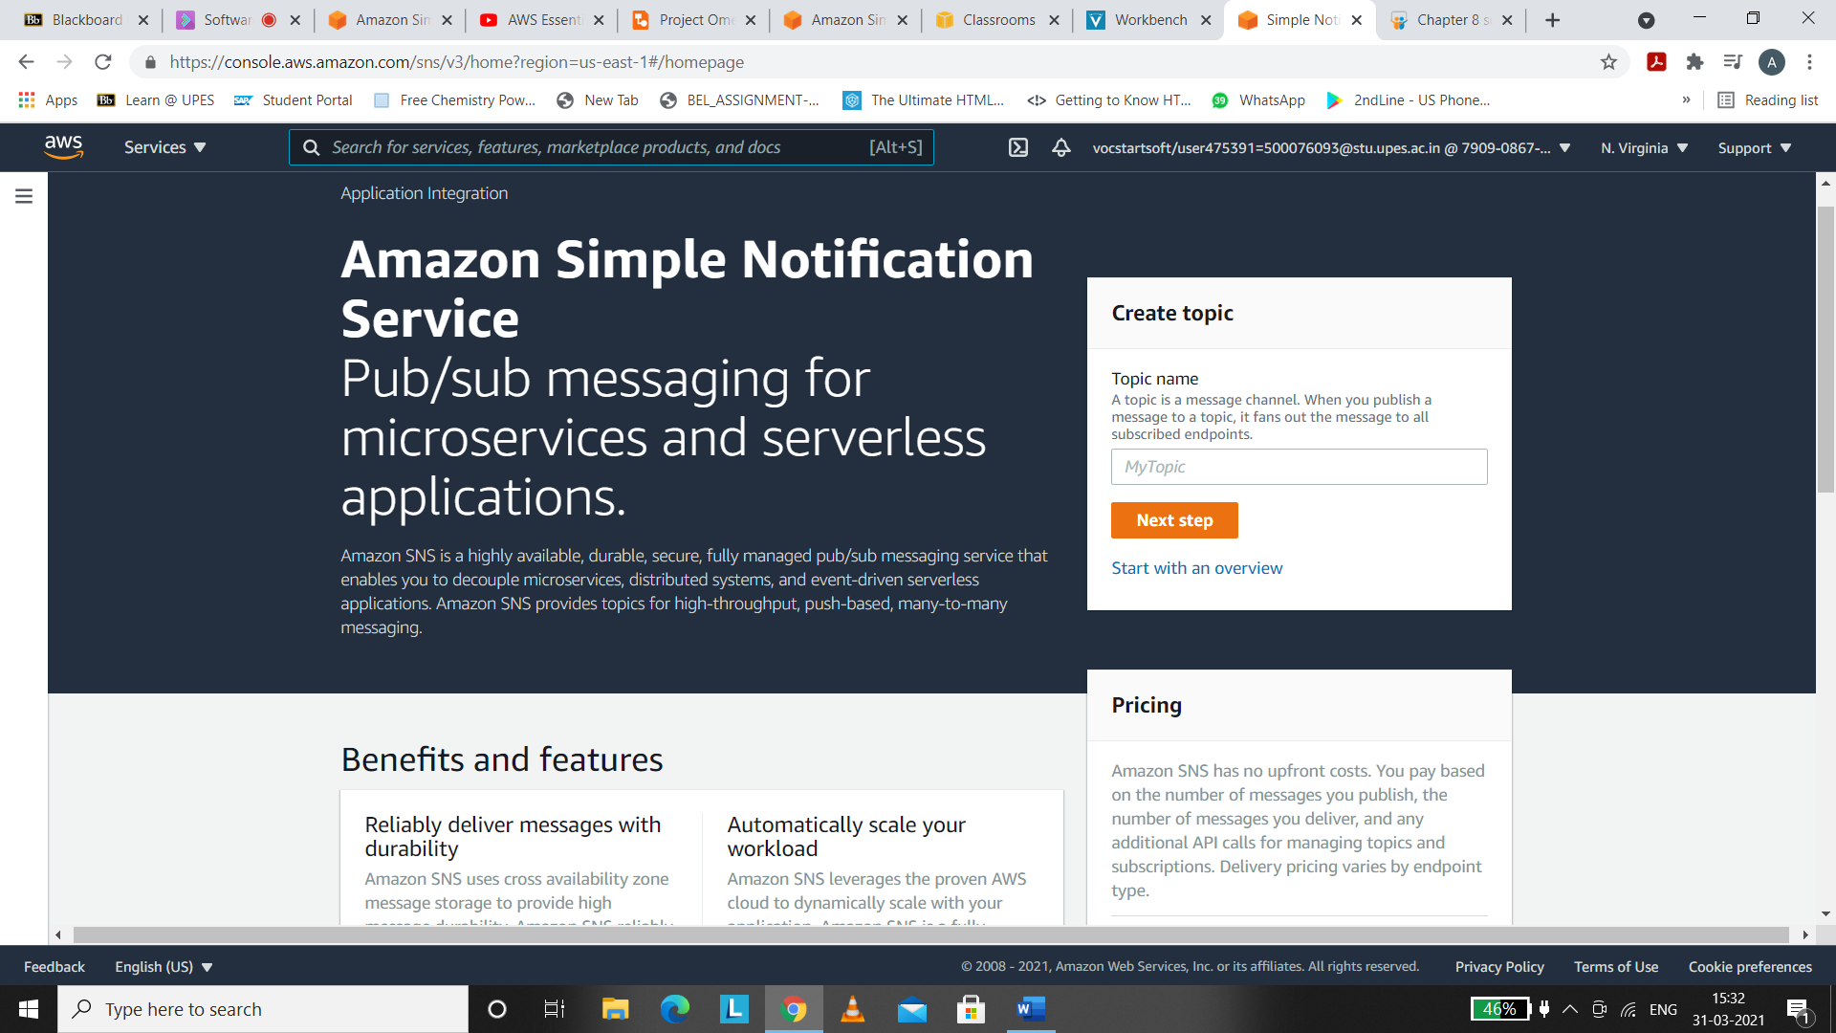

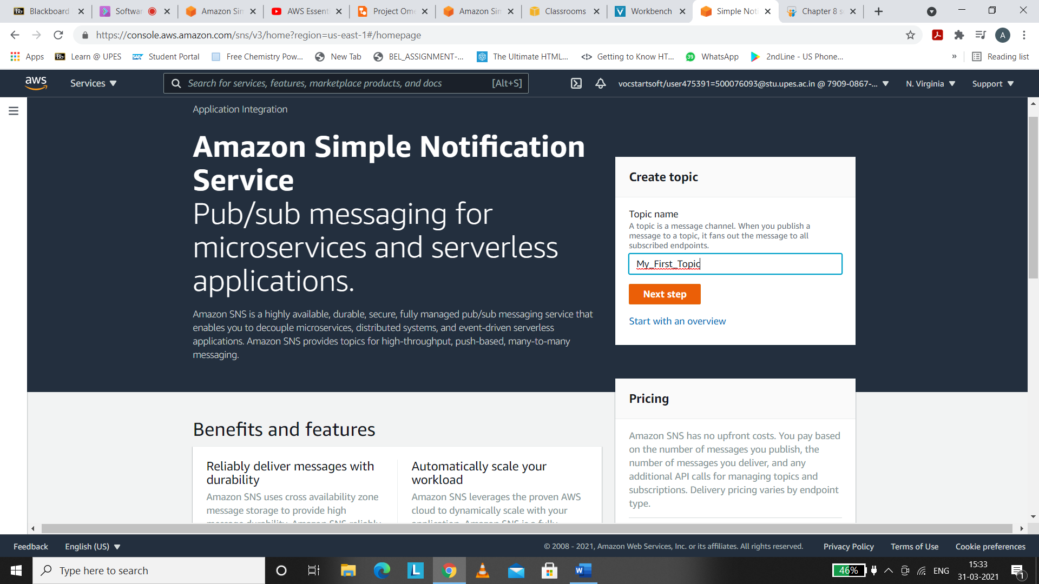

I have named my topic “My_First_Topic”

Press on Next step then.

Step 3. We can add the type , display name , tags, display logging etc. for our topic.

I will let the values to be default.

I have kept the Display name as Topic , you can name anything as you want.

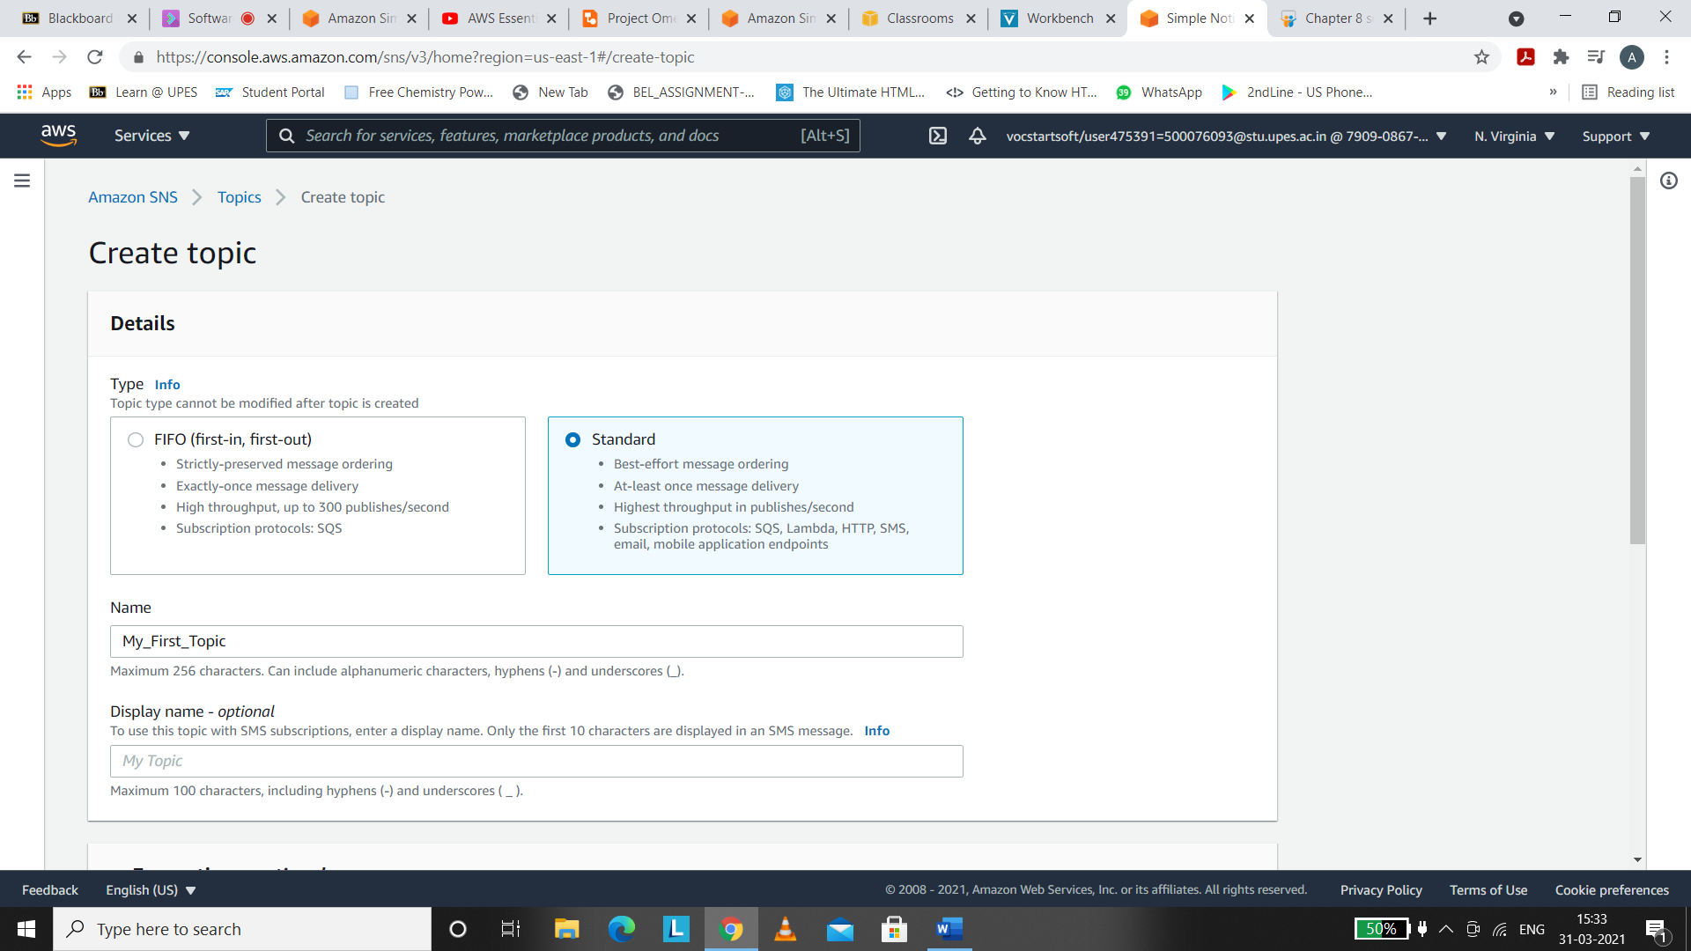

After setting values to every parameter wherever required , Click on Create Topic.

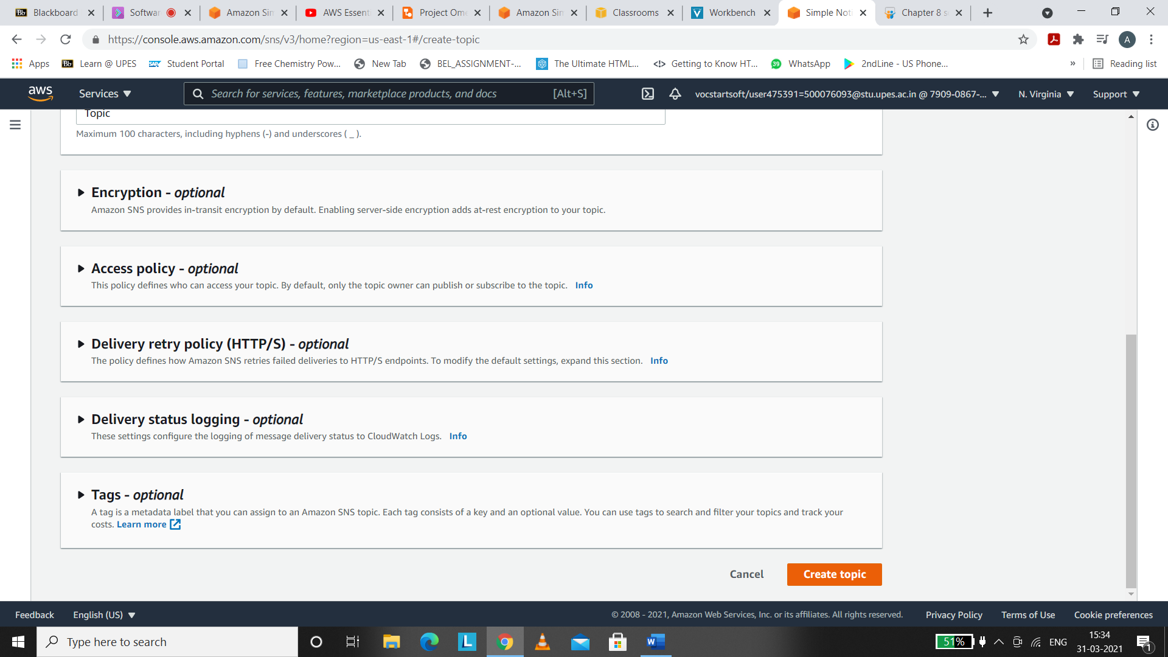

You may check the details for your topic. If you wish to edit or delete or publish any message you may do this from the below window:-

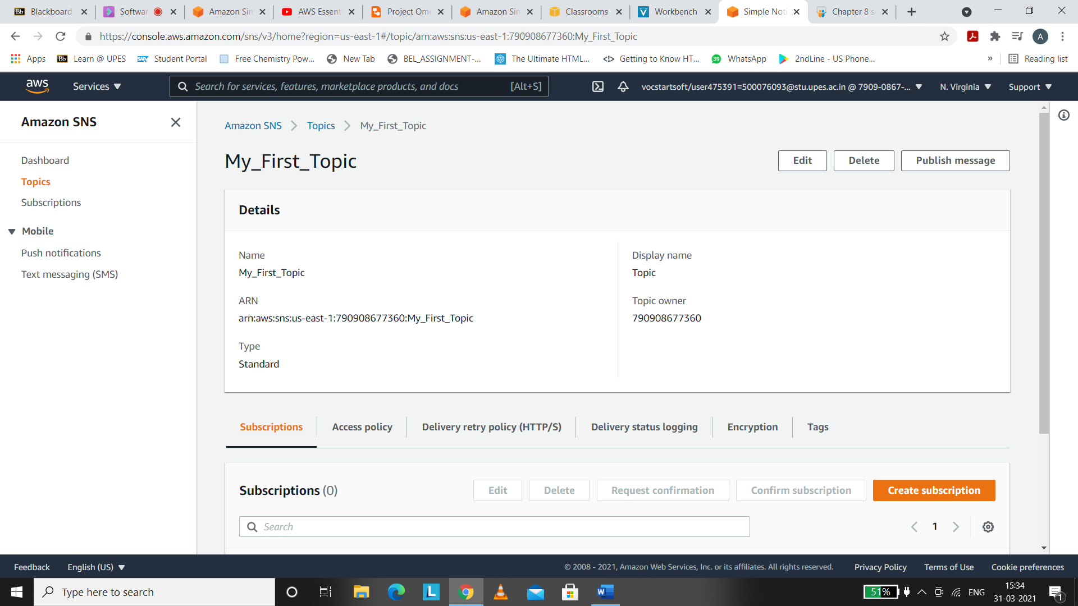

Step 4: At the bottom , Click on Create Subscription and you will get a window to set values for the subscription.

For Subscription :-

* Choose the topic you have made recently
* Select the Protocol
* As per the protocol ,set the value

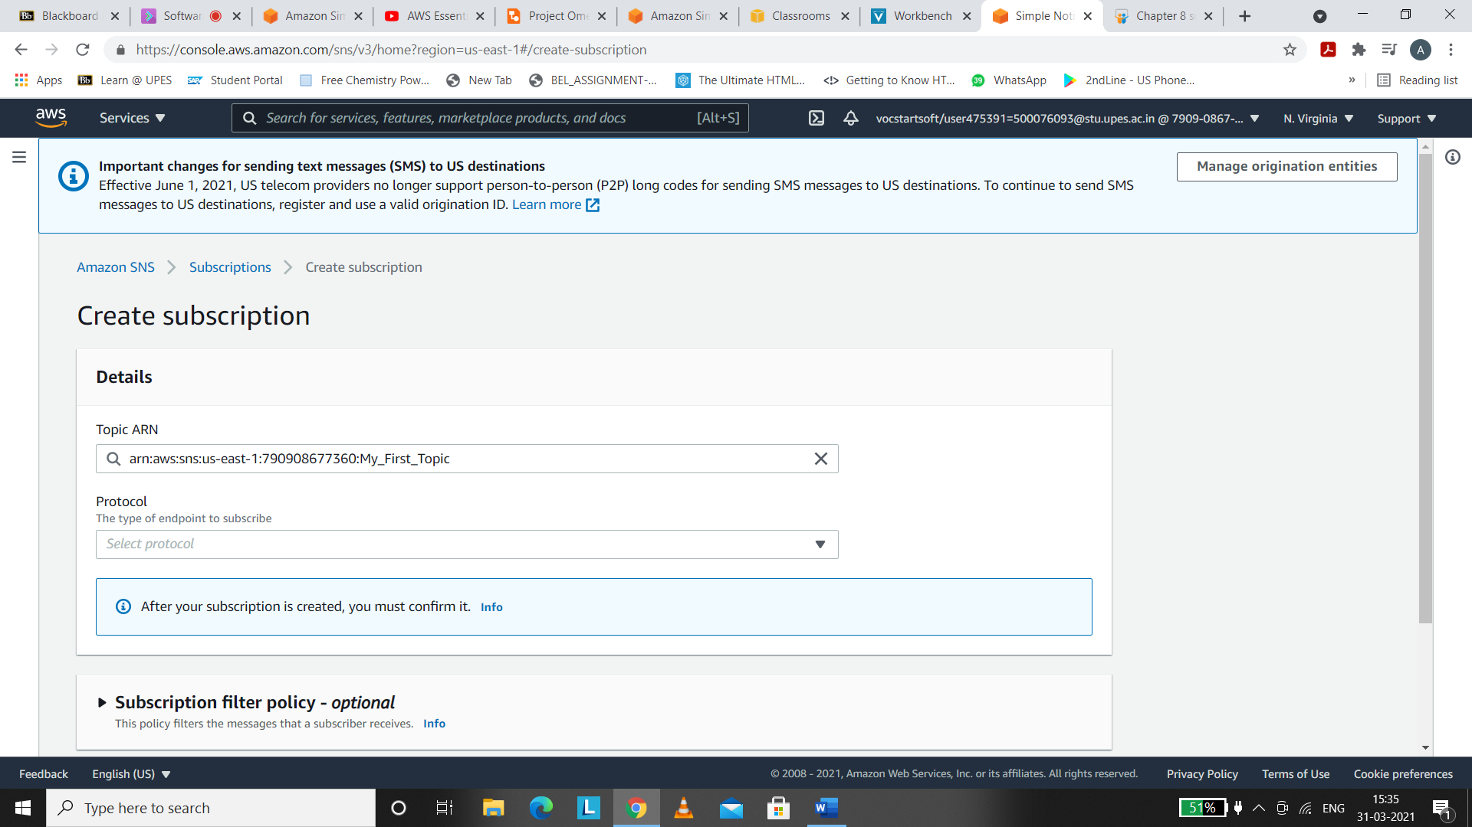

I am experimenting with Email protocol that means the message will be received on my Email.

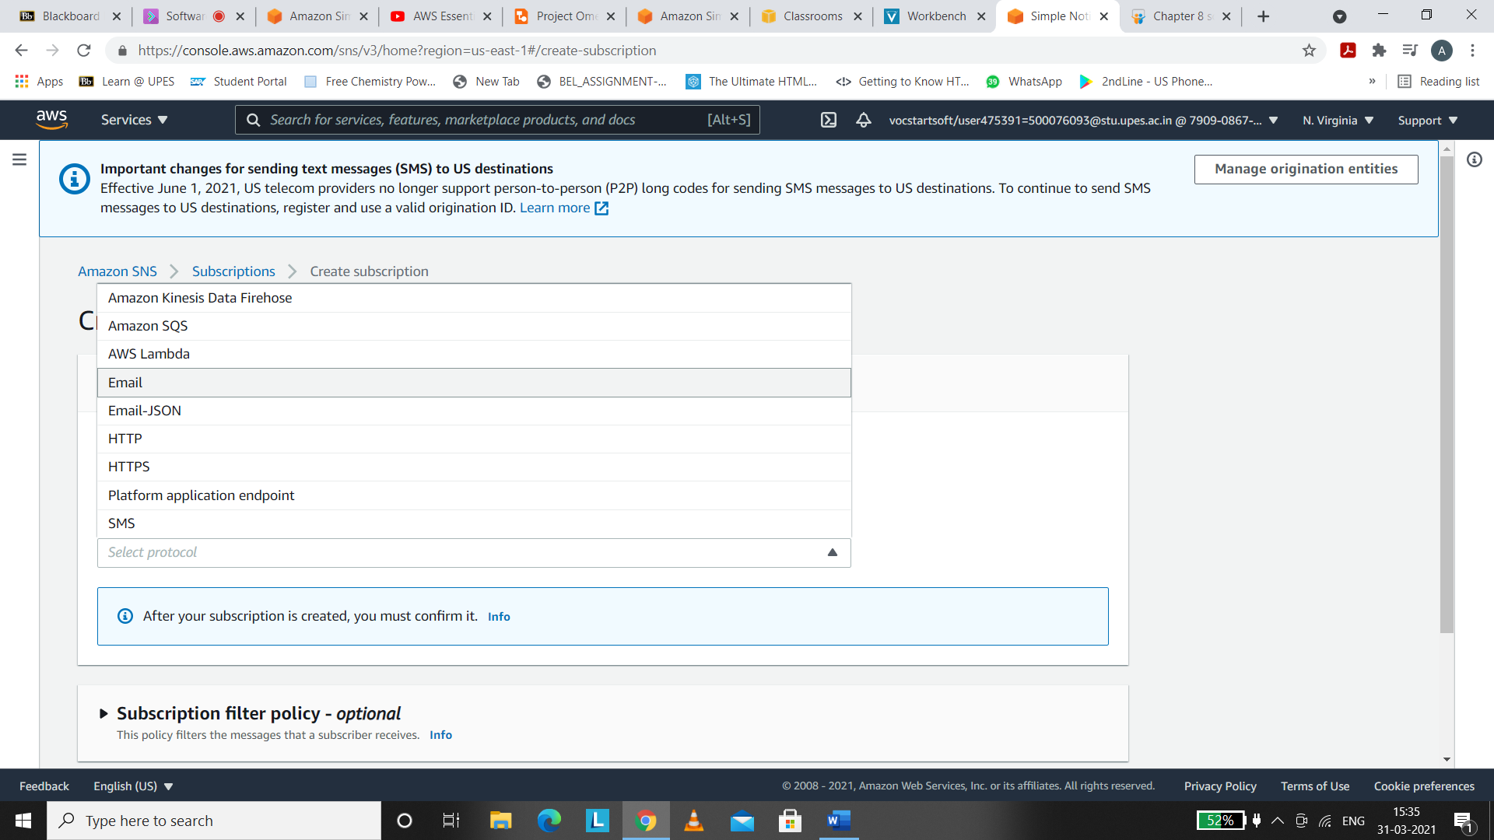

Then leave the other parameters to default.

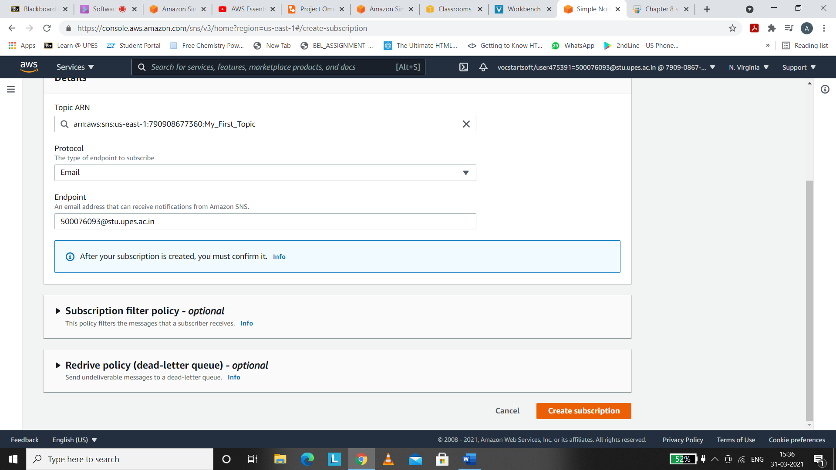

Click on “Create Subscription”

After making Subscription , you can see the Status to “Pending Confirmation” that means for now our subscription is not activated.

Step 5. For the Status to be Confirmed, Go to the email id you had put under the protocol session. Open your inbox and confirm the subscription.

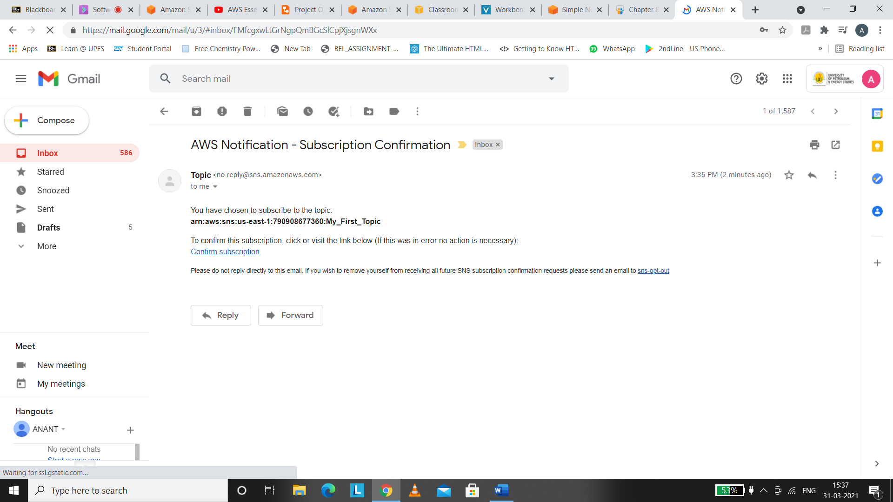



After confirming , You will receive the following message in a new tab.



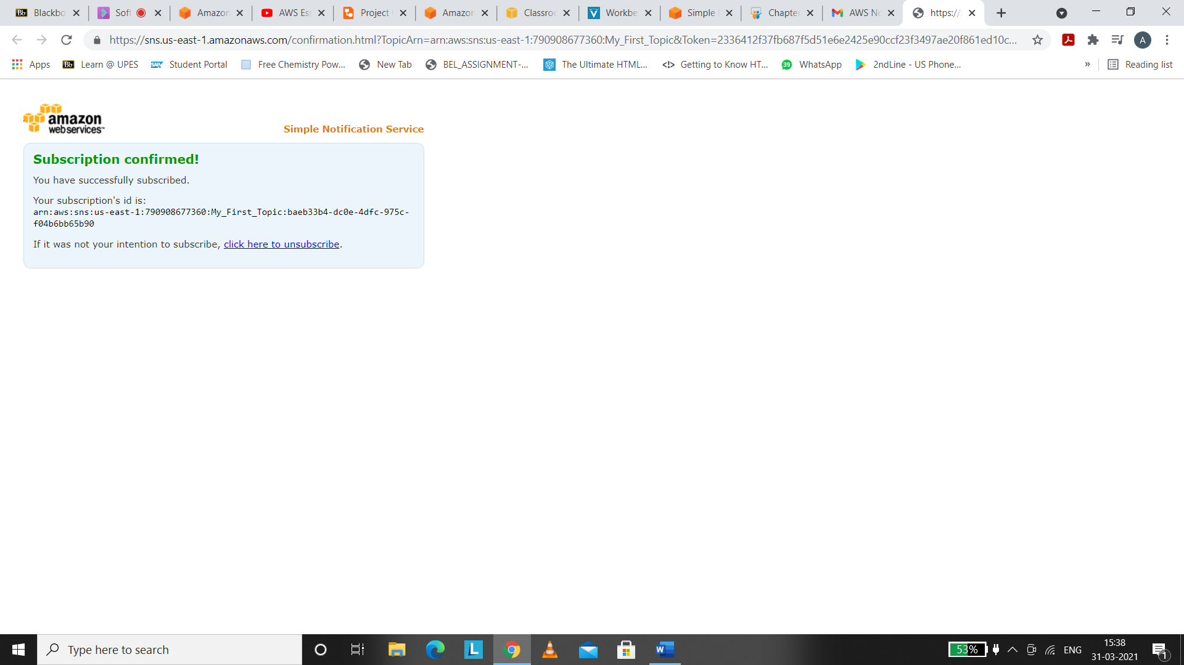



And now you can see the status has been CONFIRMED.



For checking subscriptions, you may check on the left navigation panel.

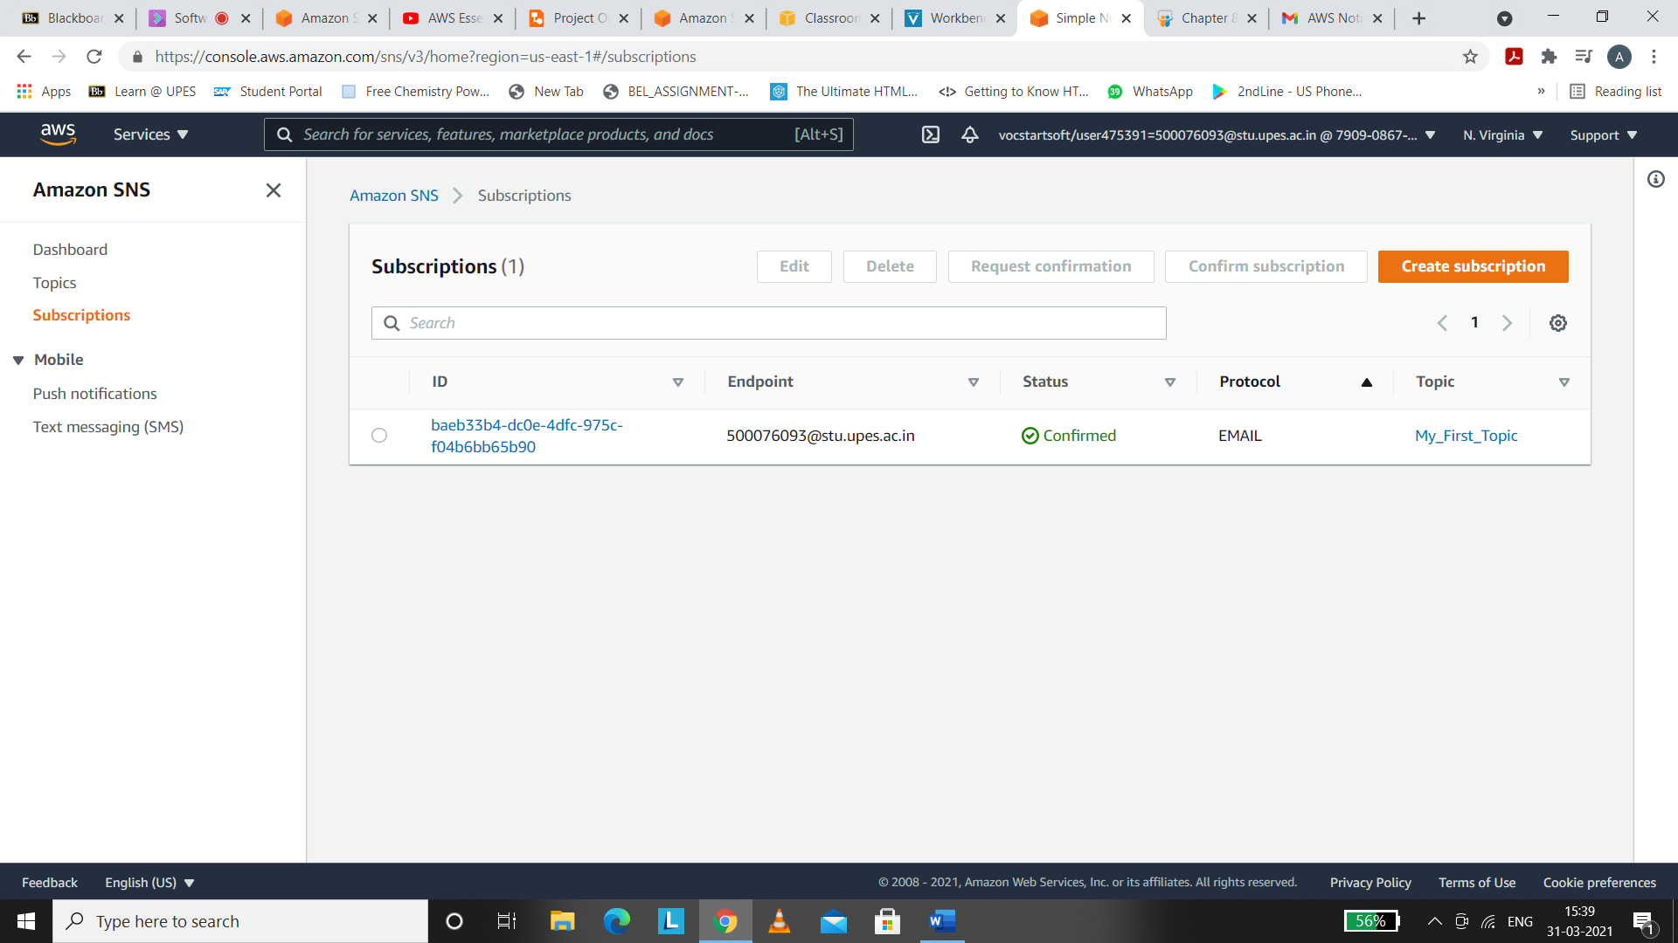

Step 6. Now Click on Topics and then click on Publish Message.

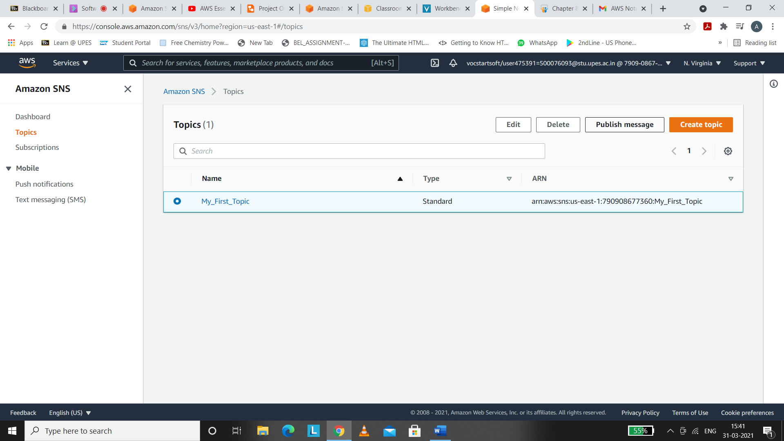

Enter the Subject if you want as it is optional column.

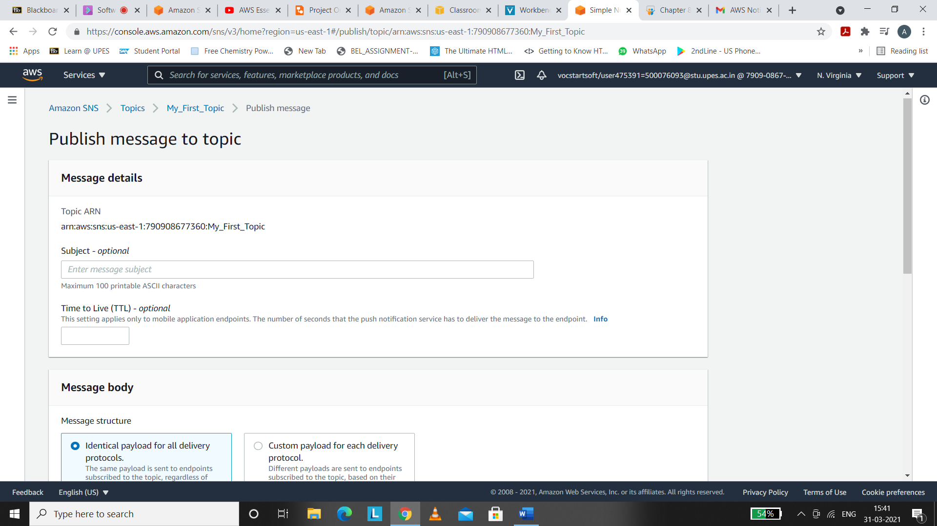

I have named it

“Test”

Scroll Down and add the message in the message body section.

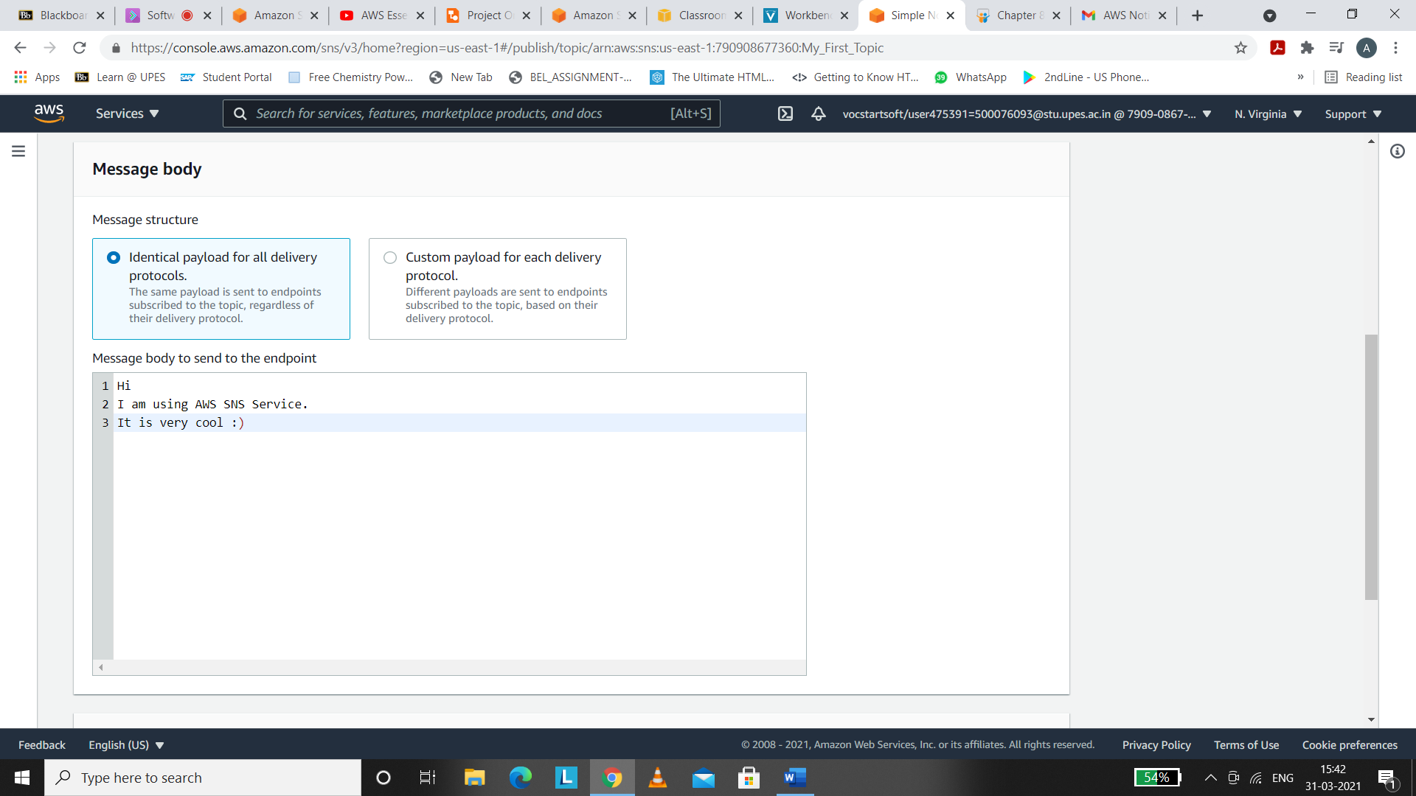

Leave the message attributes to default as they were.

Then click on “Publish Message”.

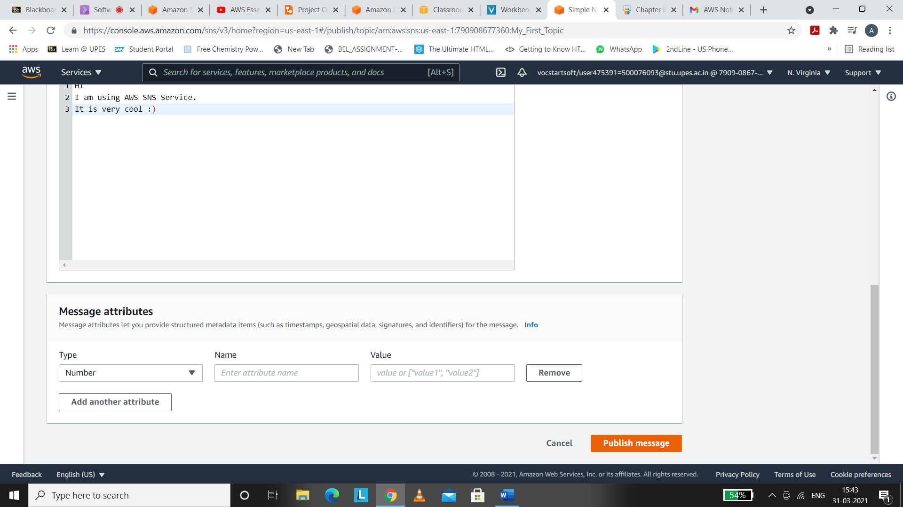

Step 7. After publishing the message , there will be message with a subject “Test” in the inbox section of your email Id.

